# Introduction

Diffusion-weighted MRI (magnetic resonance imaging) in the brain allows medical professionals to reconstruct the brain, in order to study brain anatomy and diagnose patients with potential conditions safely. Patients are exposed to a magnetic field, and the diffusivity of water in different locations of the brain tissue is measured. Through analysis of the properties of this diffusion, various figures can be produced to assist professionals with diagnosis.

# Part 1

**Report: Present the mathematical problem of fitting the diffusion tensor, which should reference Jiang, et al. [1] and the Background Reading document where appropriate (~1 page).**

## Estimating Diffusion Tensor from Raw Data

We are given a single slice of a patient’s scan, with the objective of using this data to estimate the diffusion tensor at each voxel.

From Jiang et al. (2005), we have the mathematical equation,

$$S=S_{0}e^{{-bg}^{T}Dg}$$

where *S* is the signal intensity, which decays exponentially as a function of the constant diffusion tensor $D$ (mm/s), the direction of the diffusion sensitising gradient pulse $g$ (a unit vector in ) and the parameter *b* (s/mm) the diffusion-weighting factor set by the machine operator. *b* is a scalar that absorbs all the details about the gradient pulse other than its direction, such as its strength and timing and is held constant for all the gradient pulses. The *b* value used for this analysis was 1000 s/mm (a typical value). It would be possible to change the value for alternative insights. Thus, the only independent variable changing throughout the scan are the directions $g_{i}$**.**

We use this information, with the formula above to estimate $D$, 3 x 3 symmetric positive definite matrix, at each voxel. $$D=\left[\begin{matrix}D_{xx} & D_{xy} & D_{xz} \\ D_{yx} & D_{yy} & D_{yz} \\ D_{zx} & D_{zy} & D_{zz}\end{matrix}\right]$$

Substituting these values into Jiang’s equation above, we obtain a system of $k$ equations, where $k$ is the number of directions in $g$. This can be written in matrix form. Since the initial equation is not linear, we will take the natural logarithm of each side, and construct a linear system of the form $A\overline{D}=B$, where

$A = \left[\begin{matrix}{\overline{g}}_{1}^{t} \\ {\overline{g}}_{2}^{t} \\ ⋮ \\ {\overline{g}}_{k}^{t}\end{matrix}\right]$, with $\overline{g}= {\left[\begin{matrix}g_{x}^{2} & g_{y}^{2} & g_{z}^{2} & 2g_{x}g_{y} & 2g_{x}g_{z} & 2g_{y}g_{z}\end{matrix}\right]}^{T},$ and $k=64$

$$B=-\frac{1}{b} log{(\frac{S}{S_{0}}})$$

$$\overline{D}= {\left[\begin{matrix}D_{xx} & D_{yy} & D_{zz} & D_{xy} & D_{xz} & D_{yz}\end{matrix}\right]}^{T}$$

Since we cannot find $\overline{D}$ such that $A\overline{D}=B$ exactly (the system is inconsistent), we must find the most fitting solution for $\overline{D}$ for which we can use the least squares method. The objective is to minimise the norm of the *residual*: $\left\|B-A{\overline{D}}^{*}\right\|$

Solutions to the least squares problem:

$$\overline{D} ={argmin}_{x^{*}∈R^{n}}\left\|B-A{\overline{D}}^{*}\right\|$$

can be found by solving the normal equations,

$A^{T}A\overline{D}=A^{T}B$,

finding the QR decomposition,

$$A=QR,$$

then solving the triangular linear system using backward substitution.

For efficiency, we use MATLAB’s built-in Gram-Shmidt process (since we're using floating point arithmetic to output $\overline{D}$, from which we construct our 3x3 matrix $D$.

## Results of Analysis

**Produce mean diffusivity map, fractional anisotropy map and principal diffusion direction map resembling those in the Project Description. Include these figures in your report**

From our matrix D, we can obtain eigenvalues and their corresponding eigenvectors. D, being a symmetric positive definite matrix, has real and orthonormal eigenvectors. The three eigenvalues indicate the magnitude of diffusivity in three directions (Jiang et al., 2005).

Then, some common imaging techniques for diffusion tensor imaging are as follows:

**Mean diffusivity map**

To determine the magnitude of the diffusion at each voxel, we find the mean diffusivity (mean average of all three eigenvalues) and produce the greyscale image below, simply by plotting the result. This map can help professionals monitor diffusion in the brain and signal potential areas of abnormal diffusion which may be of concern.

Map of the Fractional Anistropy


**Fractional anisotropy**

To determine the fractional anisotropy, (a measure of how the eigenvalues differ), we use the formula:

$FA=\sqrt{\frac{{\left(λ_{1}-λ_{2}\right)}^{2}+{\left(λ_{2}-λ_{3}\right)}^{2}{+\left(λ_{1}-λ_{3}\right)}^{2}}{2\left(λ_{1}^{2}+λ_{2}^{2}-λ_{3}^{2}\right)}}$ (Elster 2009),

From our image, notice the very outside of the brain, and the x-shape inside, are much brighter. Thus these areas are more anisotropic (Elster, 2009). Within these brighter sections the diffusion occurs very directionally instead of universally. Visualising this information can indicate various injuries or disease and assist in localizing them.

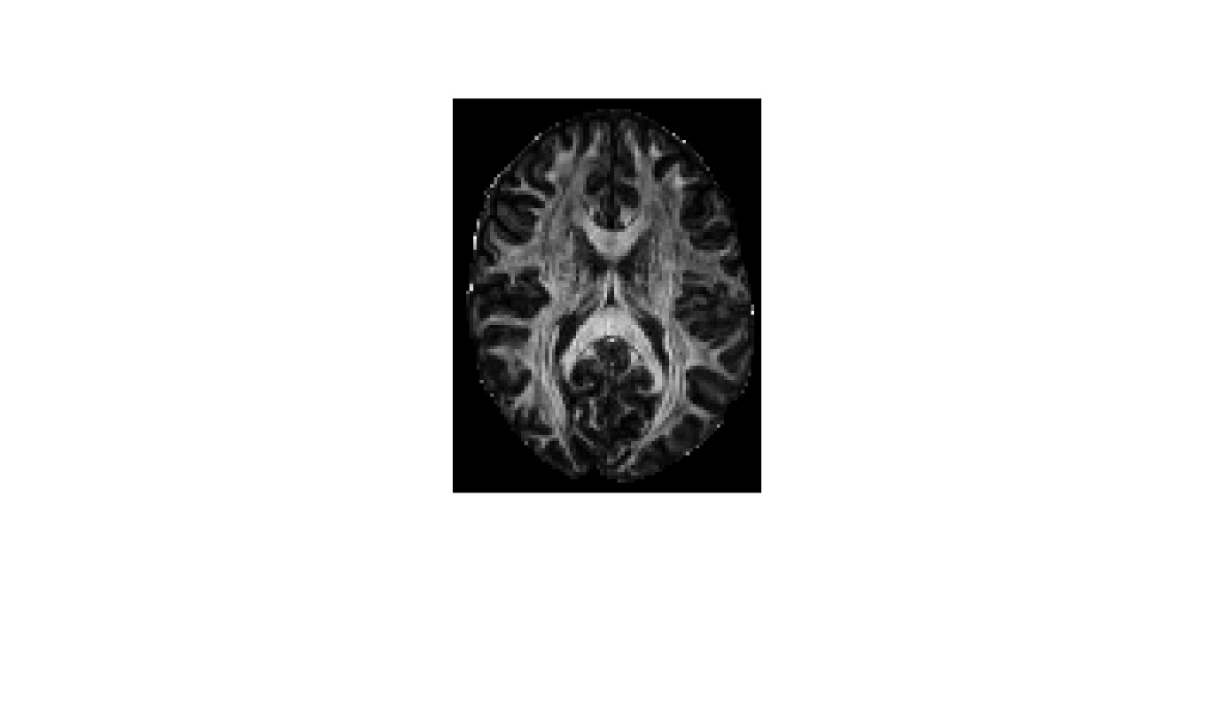

**Principal Diffusion Direction**

To determine the principal diffusion direction (the direction of strongest diffusion), we observe the eigenvector $v_{1}$ associated with the largest eigenvalue $λ_{1}$, then use Matlab to produce an image with which it can be visualised.

We use coordinates of $v_{1}$ (the Eigenvector associated with our largest Eigenvalue) to determine the red, green, and blue pixel intensities, and scale by FA to control brightness.

Thus each voxel is assigned a colour based on the principle direction of diffusion and brightness based of the directionality / relative magnitude of that diffusion. This increases the visibility of the information.

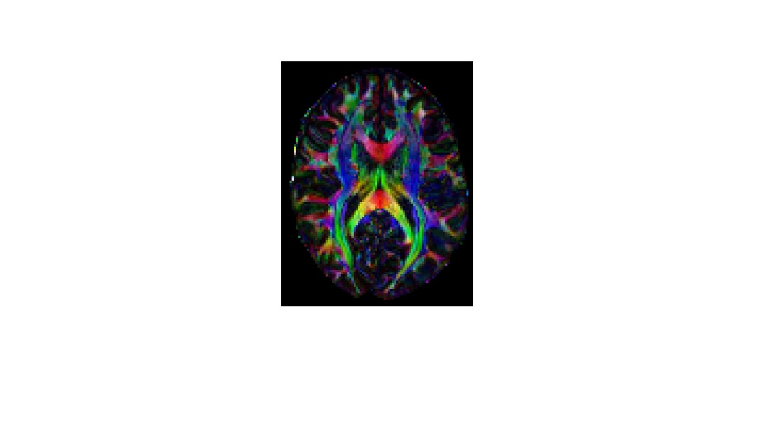

## Dealing with Noise

**Report: Describe what issues arise due to bad or invalid data at any step of the process, and explain how this is handled, with justification (~1/2 -- 1 page).**

To improve the accuracy of the estimation, we take into account noise surrounding the brain scan and remove unwanted data from our calculations.

Negative values in the dataset cause additional problems (particularly as we take the logarithm). To combat this, we can note that for S, the measure of signal intensity, “direction” is irrelevant. Thus, as we are interested in only magnitude, we use absolute values of $S$ and $S_{0}$ to remove negative readings.

To make the edges of the scan more interpretable, we apply a binary mask. This filters out irrelevant scan data by identifying actual brain tissue and excluding data outside this region from our calculations.

Despite these two techniques for reducing noise, the final Mean Diffusivity figure still displays some unwanted artifacts. This is partly due to the nature of the analysis - using an average value predisposes the image to a low contrast. Thus, a display threshold of 10% of the maximum value is put in place. This effectively increases the clarity and overall visualisation of the image.

|  |  |
| --- | --- |
| Low contrast Initial MD output | Higher Contrast output using threshold |
|  |  |

# Part 2

# Part 1 Video Script

Video: Present your group's capabilities at producing high quality MRI images, and propose how you would take this further if awarded the contract (~1 minute).

We are a team of very capable individuals, well-versed in solving neuro-imaging challenges. Our solutions enable seamless data analysis and visualisation allowing efficient and accurate patient diagnosis.

30 words

Aiden :

When given the raw data from a 2D slice of a demo MRI our analysis is already able to create multiple different figures to assist professional insights.

By measuring diffusion speed and addressing signal noise we are able to create a mean diffusion graph. *MD photo*

By Isolating the magnitude of the principle direction of diffusion and instead mapping that to brightness an entirely different view of the brain gets formed.

Our team was also able to identify the direction of diffusion and use the RGB colour space to overlay this information into the same graph allowing professionals a quicker view of whats important.

100 words

Sofia :

Given the opportunity, we are eager to further investigations through techniques such as fibre tracking maps, which provide insight into the structural connectivity of the brain, and analysis of 3D scans, in order to reproduce a comprehensive 3D model of the brain. This would significantly aid understanding of the anatomy of the brain and the speed at which diagnosis occurs.

Additionally we plan to decrease the subjectivity of manual diagnosis by developing software that automatically compares a patient’s scan to healthy brain tissue, and immediately locates anomalies whilst taking into account genetic and environmental factors such as age, gender.

100 words

3-minute recorded video presentation, pitched to a panel of digital health executives. This is a recorded presentation; you do not perform this presentation live to an actual audience. The hypothetical audience you are targeting in your video will not be as mathematically knowledgeable as you. The purpose of this video is to pitch your group as capable problem-solvers in this field of digital health, competing for a hypothetical contract. It is not the place to go into mathematical detail (the technical report covers that aspect). You should treat this as an authentic video pitch and approach it with a level of professionalism. Each group member must speak on video as part of the presentation.

You can be in the same room, or over Zoom, or with separate video sections joined together: it's up to you. The video Demo day pitch provides some good tips for structuring the presentation.

# Conclusion

**Reference list**

Elster, AD 2009, DTI, Questions and Answers ​in MRI, viewed 15 May 2024, <https://mriquestions.com/dti-tensor-imaging.html>.

Jiang, H, C.M, P, Kim, J, Pearlson, GD & Mori, S 2005, ‘DtiStudio: Resource program for diffusion tensor computation and fiber bundle tracking’, *Computer Methods and Programs in Biomedicine 81* , vol. 81, no. 2, pp. 106–116, viewed 10 May 2023, <http://individual.utoronto.ca/ktaylor/DTIstudio_mori2006.pdf>.

Moroney, T 2024, *MXB201 Project Description*, *QUT Canvas*, viewed 1 May 2024, <https://canvas.qut.edu.au/courses/17944/assignments/164926>.